**PROJECT REPORT**

On

**MOBILE APP BASED WIRELESS ROBOT FOR MONITORING HEALTH, PROVIDING FOOD AND MEDICINES TO COVID PATIENT**

Submitted for Partial Fulfilment of Award of

**BACHELOR OF TECHNOLOGY**

**In**

**Electronics & Communication Engineering**

(2022)

By

**SWARAJ SINGH (1812231139)**

**PALLAVI PANDEY (1901220319006)**

**RITPURNA GUPTA (1901220319006)**

Under the Guidance

Of

**Er. Rahul Mishra**



**SHRI RAMSWAROOP MEMORIAL COLLEGE OF ENGINEERING AND MANAGEMENT, LUCKNOW**

Affiliated to

**Dr. APJ ABDUL KALAM TECHNICAL UNIVERSITY,**

**LUCKNOW**



**Department of Electronics and Communication Engineering**

**SRMCEM**

## CERTIFICATION

Certified that the project entitled “**MOBILE APP BASED WIRELESS ROBOT FOR MONITORING HEALTH AND PROVIDING FOOD AND MEDICIN**

**TO COVID PATIENT.** “Submitted by **Swaraj Singh [1812231139], Pallavi Pandey [1901220319005] and Ritpurna Gupta [1901220319006]** in the partial fulfilment of the requirements for the award of the degree of Bachelor of Technology (Electronics and Communication Engineering) of Dr. A.P.J. Abdul Kalam Technical University, is a record of students’ own work carried under our supervision and guidance. The project report embodies results of original work and studies carried out by students and the contents do not forms the basis for the award of any other degree to the candidate or to anybody else.

|  |  |
| --- | --- |
| **Er. Rahul Mishra** | **Prof. (Dr.) Indu Prabha Singh** |
| (Assistant Professor) | (Associate Director (Engg.)) |
| (Project Guide) | (Head of Department) |

|  |
| --- |
|  |
|  |



**Department of Electronics and Communication Engineering**

**SRMCEM**

**DECLARATION**

We hereby declare that the project entitled “**MOBILE APP BASED WIRELESS**

**ROBOT FOR MONITORING HEALTH AND PROVIDING FOOD AND MEDICINE TO COVID PATIENT.”** submitted by us in the partial fulfilment of the requirements for the award of the degree of Bachelor of Technology (Electronics and Communication Engineering) of Dr. A.P.J. Abdul Kalam Technical University, is record of our own work carried under the supervision and guidance of **Er. Rahul Mishra** (Assistant Professor).

To the best of our knowledge this project has not been submitted to Dr. A.P.J. Abdul Kalam Technical University or any other University or Institute for the award of any degree.

**Swaraj Singh Pallavi Pandey Ritpurna Gupta**

**(18112231139) (1901220319005) (1901220319006)**



**ACKNOWLEDGEMENT**

The success and accomplishment of a project requires a lot of guidance and assistance from many people who impart their knowledge and ideas to bring out the final result. We are extremely fortunate to have such guidance for completion of our project work. It wouldn’t have been possible to bring this journey so far without such support and guidance.

We take this opportunity to express our profound gratitude and deep regards to our Project Guide **Er. Rahul Mishra** (Assistant Professor, ECE Department) for his exemplary guidance, monitoring and constant encouragement throughout the course of this project. The blessing, help and guidance given by him from time to time shall carry us a long way in the journey of life on which we are about to embark. He gave us the complete freedom to work on this project and embellished our raw ideas into the best of his knowledge. We are beholden to him for giving his valuable time during this project.

We owe our thanks to **Prof. (Dr.) Indu Prabha Singh** (Associate Director (Engg.) and Head of the Department, ECE Department) for providing us her meaningful help and support, till the completion of our project.

We would specially like to thank our Project Coordinators, **Dr. Vikrant Bhateja** (Associate Professor, ECE Department) and **Er. Uddaish Porov** (Assistant Professor, ECE Department) who had given us the permission to work on this project. Without their consent we would not be able to implement our imagination in a real model. They provided us with indispensable ideas that helped us in improving our project. We are thankful to them for encouraging and motivating us in every stage of our project. In the end we would like to thank each and every person who was there in various stages of our project to give us their help and support. Without their help this project could not have been this successful.

**Swaraj Singh Pallavi Pandey Ritpurna Gupta**

**1812231139 1901220316005 1901220319006**

**PREFACE**

The aim of this project report is to develop a mobile based distance operated Robotics vehicle for providing food, medicines to Covid-19 patients and also monitoring their health using Bluetooth technology. At first, we will gather the data of temperature, heart rate, oxygen level, by using sensors. The sensor and coding procedures took almost 8 weeks to finish followed by the construction of hardware.

The following chapter will shed some light on the work.

**Chapter 1**: Introduction of the simplistic ideas of the project and explains its need in the present time, giving a brief scope of the project and the design proposal.

**Chapter 2:** Give brief Information about the various norms that have been passed in the past by various organizations focusing on the necessity of the project. It also gives a little review of some related works that have been done by various manufacturers on some of their models.

**Chapter 3:** Discusses the procedure of problem formulation along with discussing the proposed methodology that has been formed to solve the problem, giving details about the block diagrams and their explanations. It gives the complete information about the hardware, software and other technologies which were used for making the project. Each of the major components used are discussed in this chapter.

**Chapter 4:** Discusses the final result with the help of some data of the project.

**Chapter 5:** Concludes the report, discusses the advantages, limitations and applications of the project.

**Chapter 6:** Hints towards the future scope of the project.

**Chapter Organization-**

**Chapter 1- *Introduction****.*

Doctors and health worker must go through a major battle amid the corona virus pandemic. It’s definitely an exhausting time for them to cover themselves with layers of PEP. The robot is helping that hospital staff to serve food and medicines to COVID-19 patients while avoiding physical contact. The robot sensor can read a patient’s body temperature and pulse rate by using Smartphone.

**Chapter 2** – ***Literature Survey***

**Chapter 3** – ***Proposed Methodology***

**Chapter 4** – ***Result Analysis and Discussion***

**Chapter 5 – *Conclusion***

**Chapter 6 – *Future Scope***

* Independent health monitoring.
* Medicines on Right time.
* This is Bluetooth application based, also used for wireless applications.

**ABSTRACT**

Healthcare monitoring system in hospitals and many other health centres has experienced significant growth, and portable healthcare monitoring systems with emerging technologies are becoming of great concern to many countries worldwide nowadays.

The advent of smart phone facilitates the progress of healthcare from face-to-face consulting to telemedicine. This paper proposes a smart healthcare system in environment that can monitor a patient’s basic health signs as well as the room condition where the patients are now in real-time. In this system, two sensors are used to capture the data from hospital environment named heart beat sensor, body temperature sensor. The error percentage of the developed scheme is within a certain limit (< 5%) for each case. The condition of the patients is conveyed via a portal to medical staff, where they can process and analyse the current situation of the patients. The developed prototype is well suited for healthcare monitoring that is proved by the effectiveness of the System.

**Keywords:** Robotics, D.C drive, Rack and Pinion mechanism, Healthcare monitoring system, Max30100 Sensors,

**TABLE OF CONTENTS**

**CERTIFICATE ii**

DECLARATION iii

ACKNOWLEDGEMENT iv

PREFACE vi

ABSTRACT vii

1. **TABLE OF CONTENT**

**CHAPTER – 1**

**INTRODUCTION**

**1.1 General**

Doctors and health workers have to go through a major battle amid the coronavirus pandemic. It's definitely an exhausting time for them to cover themselves with layers of PEP kit and then ensure social distancing. To protect the health workers from COVID-19 infection, the East Coast Railways Central Hospital in Odisha is using a Medical Robot called MED ROBO to provide medicines, food and remote assistance to patients in the coronavirus ward, without any need for physical contact. The MeD ROBO is operated through a unique mobile app that has been developed as part of the innovation, supported by the Wi-Fi facility, an ECoR official said. The robot is helping that hospital staff to serve food and medicines to COVID-19 patients while avoiding physical contact. The robot’s sensor can read a patient's body temperature and transmit the same for display on the smartphone. In case of any abnormal high-temperature reading, the MeD ROBO is capable of raising an alarm so as to alert the hospital staff attending to the patients. "Hi, I'm LaLuchy Robotina! What's your name?" the 1.4-meter-tall (4.6 feet) robot asks patients as it goes from room to room. It moves around on wheels and has a camera and display screen enabling relatives and doctors to chat with patients or staff in full protective gear in the coronavirus ward. "It allows us to have a physical presence but with zero exposure to aerosols within the Covid-19 area," said Lucia Ledesma, a neuropsychologist at the November 20 National Medical Center.Robots are used to serve humanity. The branch of robotics that plays such a vital role is called “social robotics”. Social robots in today’s scenario are now communicating with human, interacting and relating to society in all aspect and are capable of understanding social terms. Due to the modernization in robotic technologies, many new designs and mechanisms are being implemented which are able to read human thoughts and understand actions. Such robots find vast applications in assistive robotics e.g., to help out injured, sick and elder people. Theses robots are adaptive, i.e., they can be used in multi-mode as per scenario. So far, the robots are those who learn from us, but that time will not be so far when the teacher will then be learner.

* Doctors and health workers have to go through a major battle amid the corona virus pandemic.
* It's definitely an exhausting time for them to cover themselves with layers of PEP kit and then ensure social distancing.
* The robot is helping that hospital staff to serve food and medicines to COVID-19 patients while avoiding physical contact.
* The robot’s sensor can read a patient's body temperature and pulse rate by using Smartphone.

COVID-19 has a various effect on various persons. The majority of the infected people will experience somewhere mild to moderate symptoms and will recover without the need for hospitalization by consuming basic medicines like Paracetamol, Azithromycin, Zinc, etc.

Healthcare workers are continuously facing serious workplace hazards. Nowadays, during the time of the COVID-19 pandemic, healthcare workers have an increased risk of contracting COVID-19 due to their contact with patients affected by the new coronavirus. In addition, workers in healthcare settings may be exposed to flu germs, blood borne pathogens (such as HBV and HIV), hand-washing related infections and many other healthcare-associated infections and diseases. Shortage of staffing and, in particular, nursing shortage is an additional major concern in many hospitals. Healthcare organizations in the near future will likely face much more shortage of nurses than in nowadays. Due to nursing shortage, nurses working in a healthcare organization often have to considerably extend their work shifts, or even to work overtime shifts. Thus, nurses are at high risk for fatigue and burnout, which consequently may negatively affect the patients’ care. Given that the number of caretakers and nurses is constantly decreasing, hospital management struggles a lot to provide quality treatment to patients, even in tier-1 hospitals.

**1.1.2 HOSPITAL ROBOTS**

There are many technological developments aiming in automating hospital processes and reducing the risks in a hospital environment. Robots, for example, are started to be used in smart hospital environments for performing various activities. In particular, patient caretaker robots have the potential to provide solutions to some of the aforementioned problems. Caretaker robots can be helpful to decrease nurses’ workload and efficiently minimize nonvalue‐added nursing activities. Nevertheless, the major essential issues in the case of Autonomous Nursing Robots are effective robot path planning for the delivery of medicines to patients, measuring the patient body parameters through sensors, interacting with and informing the patient, by means of voice-based modules, about the doctors visiting schedule, his/her body parameter details, etc. All these requirements should be taken into consideration simultaneously, instead of supporting each one of them separately.

**1.1.3  SERVING ROBOTS IN HOSPITAL**

There are many tasks in hospital where pushing and pulling of material is required. These heavy-duty tasks can be easily carried out by using serving robots. Robots are also deployed to supply food to various patients residing in hospital. They are used in the delivery of food and beverages, dispensing of drugs, removing of unclean laundry, delivery of fresh bed linen, and transportation of regular and contaminated waste etc inside the hospital as shown in figures below -

[[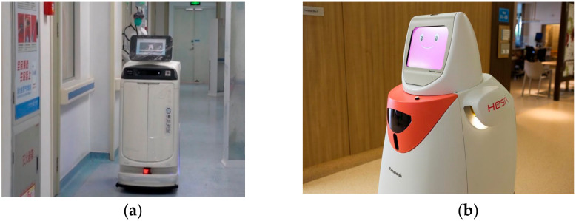](https://www.ncbi.nlm.nih.gov/core/lw/2.0/html/tileshop_pmc/tileshop_pmc_inline.html?title=Click%20on%20image%20to%20zoom&p=PMC3&id=7312924_ijerph-17-03819-g008a.jpg)](https://www.ncbi.nlm.nih.gov/core/lw/2.0/html/tileshop_pmc/tileshop_pmc_inline.html?title=Click%20on%20image%20to%20zoom&p=PMC3&id=7312924_ijerph-17-03819-g008a.jpg" \t "tileshopwindow)

[[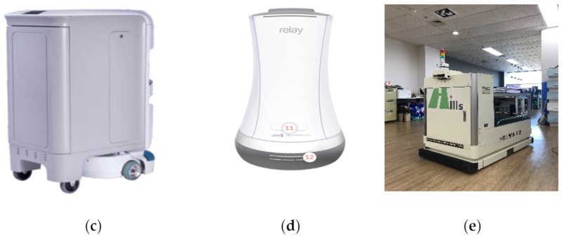](https://www.ncbi.nlm.nih.gov/core/lw/2.0/html/tileshop_pmc/tileshop_pmc_inline.html?title=Click%20on%20image%20to%20zoom&p=PMC3&id=7312924_ijerph-17-03819-g008b.jpg)](https://www.ncbi.nlm.nih.gov/core/lw/2.0/html/tileshop_pmc/tileshop_pmc_inline.html?title=Click%20on%20image%20to%20zoom&p=PMC3&id=7312924_ijerph-17-03819-g008b.jpg" \t "tileshopwindow)

**1.2 Clinical Findings:**

Coronavirus usually has respiratory symptoms. Some infected individuals have symptomatic symptoms, while others have asymptomatic symptoms. Symptoms can be mild, some with moderate symptoms and some with severe symptoms.

**1.2.1 Mild Symptoms:**

* Fever
* Cold
* Cough
* Tiredness
* Loss of taste and smell

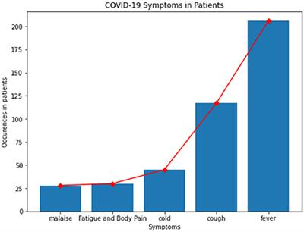

**Fig. 1.1 Plot between Occurrence in Patients Vs Symptoms**

**1.2.2 Moderate Symptoms:**

* Sore throat
* Headache
* Aches and pains
* Diarrhoea
* Skin rash, or fingers and toes discoloration
* Red or irritated eyes

**1.2.3 Severe Symptoms:**

* Difficulty breathing and shortness of breathe
* speech Loss or mobility, or confusion
* Chest pain
* Lung’s infection
* Pneumonia

If a person is experiencing severe symptoms, then he/she must consult the doctor. Always call ahead of time before going to the doctor or medical health facility.

Mild symptoms should be taken care by people at home who are otherwise healthy.

On an average It takes 5-6days for symptoms to appear if a person is infected with the virus, but it can take up to 14days. If a person got infected then the person should at least isolate himself for at least 14days.

**1.3 High-Risk Group of Population**

The virus that causes Covid19 affects people of all ages. However, previous evidence suggests that two groups of people are at increased risk of developing severe Covid19 disease:

* Elder people (people over 70 years of age)
* People with serious chronic illnesses such as:
* Diabetes
* Cardiovascular disease
* Chronic respiratory disease
* Cancer
* Hypertension
* Chronic lung disease
* Chronic liver disease
* Asthma
* Children with obesity

WHO announces and publishes recommendations for supporting these high-risk groups and communities It protects the largest segment of the population from COVID 19 without isolation, stigma, increased vulnerability, or access to basic services and social care. This is to guarantee that.

**Project Image**

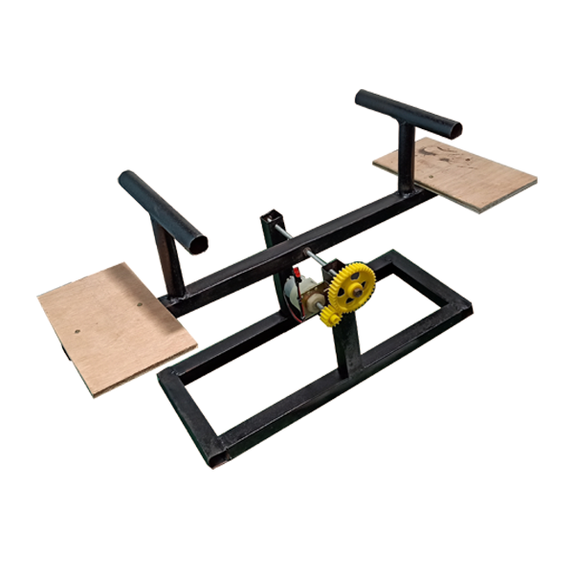

**CHAPTER 2:**

**LITERATURE SURVEY**

**2.1 GENERAL**

Mobile app based wireless robots have a high Demond during covid pandemic,

which monitor the health condition of the covid patient and also serve food and

medicine to the covid affected patient because we all know about corona viruses

it is very dangerous for any human being and Doctors and health workers have to go through a major battle amid the corona virus pandemic.

It's definitely an exhausting time for them to cover themselves with layers of PEP kit and then ensure social distancing.

The robot is helping that hospital staff to serve food and medicines to COVID-19 patients while avoiding physical contact.

The robot’s sensor can read a patient's body temperature and pulse rate by using Smartphone.

**2.2 PREVIOUS WORKS**

**1.The Internet of Things for Health Care: A Comprehensive**

**Survey**

(S.M. Riazulislam), 2015,The IoT revolution is redesigning modern health care with promising technological, economic, and social prospects. This paper surveys advances in IoT-based health care technologies and reviews the state-of-the-art network architectures/platforms, applications, and industrial trends in IoT-based health care solutions. In addition, this paper analyses distinct IoT security and privacy features, including security requirements, threat models, and attack taxonomies from the health care perspective. **Take to reference [5].**

1. **Mobile Health (m-Health) System in Context of IoT**

(S.H. Almotiri), 2016,In this paper we describe the mobile health (m-health) system in the context of Internet of Things (IoT). We discuss acquisition of mobile health data via medical gadgets and wearables and application of this data in monitoring various health conditions such as blood sugar level, ECG, blood-pressure, asthma, etc. Security is very critical for IoT based m-health system. We address the issues of confidentiality, privacy and security in the context of secure m-health system. We listed several measures to protect the information of patients and m-health system. The m-health system will benefit the patients in many ways such as quick diagnosis, remote monitoring and home rehabilitation. **Take to reference [1].**

**3. Development of Smart Healthcare Monitoring System in IoT Environment.**

(Md. Milon Islam),2020,Healthcare monitoring system in hospitals and many other health centers has experienced significant growth, and portable healthcare monitoring systems with emerging technologies are becoming of great concern to many countries worldwide now a days. This paper proposes a smart healthcare system in IoT environment that can monitor a patient’s basic health signs as well as the room condition where the patients are now in real-time. In this system, five sensors are used to capture the data from hospital environment named heart beat sensor, body temperature sensor, room temperature sensor. **Take to reference [8].**

The robot is helping that hospital staff to serve food and medicines to COVID-19 patients while avoiding physical contact. The robot's sensor can read a patient's body temperature and transmit the same for display on the smartphone. In case of any abnormal high-temperature reading, the MeD ROBO is capable of raising an alarm so as to alert the hospital staff attending to the patients. All the project related information is described in fig.

**CHAPTER 5**

## CONCLUSION

**5.1: GENERAL CONCLUSION**

In practice, digitalisation and automation did not progress fast before 2020 due to multiple reasons. The cost of robots are high and the implementation is hesitating against the cheap labour. There are political and social concerns of the fear and unknown consequences, while some of the technologies are banned at the legal level. However, the pandemic crisis forced the digital transformation to some degree [142]. Until late 2020, the pandemic was still not well controlled globally. Many automation devices and systems have been deployed worldwide to fight against the crisis [143,144]. Robot is one of the promising devices as it provides physical functionalities with effective social distancing among the patients and the medical staff.

**ADVANTAGE**

**The advantage of mobile app based wireless robot system are many as discussed below-**

* Maintain Social Distance in Hospitals.
* Easy to monitor Covid patients.
* Protect the medical person from Covid disease.
* Less human effort.
* Less employ requirement.
* Protect the medical person from covid disease.

**LIMITATION**

**The limitation of this wireless robot system are many as discuss below-**

* It is based on electronic device so due to high temperature circuit may fail.
* Sensor can fail if voltage fluctuation will happen.
* Range is limited to only 15.

**DISADVANTAGE**

**The disadvantage of this mobile app based wireless robot are below-**

* After monitoring the patient robot required to sanitize.
* Charging Requirement of the robot
* Technical Operator required.
* Time to time maintenance required.

**APPLICATION**

* It can be used in hospital for maintaining the social distance. between the infected patients and hospital staff.
* It help full in hotels and restaurants it can be used.
* It can also be used in all health checkup labs.
* This is Bluetooth application based, also used for wireless application
* In a hotel and restaurants, we can use this because by using this we can reduce the direct contact of people serving of food and other anilities by using the robot.
* All health check-up labs can use this due to this no need of any helper or extra person to carry the sample from one place to another.
* This is Bluetooth application based do we can use this device for wireless movement of product or for short transportation using mobile phone command.

**CHAPTER 3**

**PROPOSED METHODOLOGY**

**3.1 FORMULATION & PRESENTATION OF PROBLEM:**

**3.1.1 AIM OF THE PROJECT**

To develop a mobile based distance operated Robotic vehicle for providing food, medicines to Covid-19 patients and also monitoring their health using Bluetooth technology.

**3.1.2 OBJECTIVES OF THE PROJECT**

* Development of the mechanical structure of the receiver consisting of metal frame wheel based robotic vehicle structure.
* Development of android app for communicating with robotic vehicle using mobile phone via Bluetooth technology.
* Development of PCB to control robotic vehicle movement consisting of Bluetooth, sensor, motor drives and microcontroller.
* Development of software in Arduino IDE for controlling robotic vehicle movements.
* Interfacing of smartphone with robotic vehicle and its final testing.

**Hardware Block Diagram**

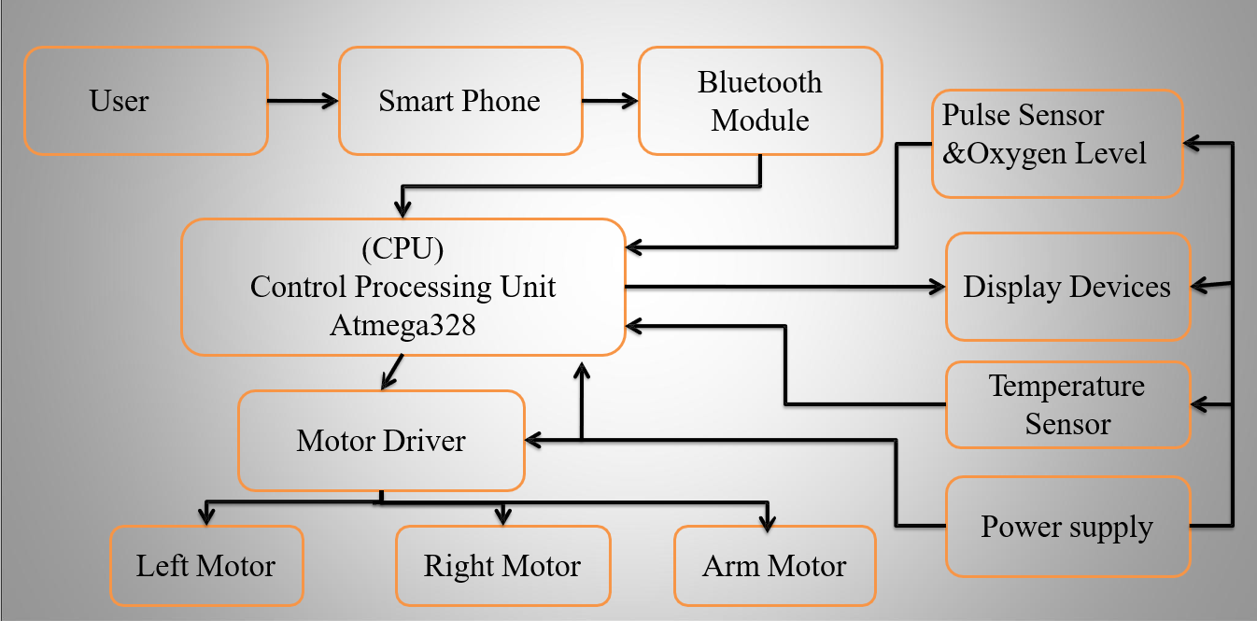

**Fig. No.**

**3.4 SOFTWARE AND HARDWARE REQUIREMENTS**

**3.4.1 SOFTWARE PREREQUISITES**

Software’s those are required for the development of –

**3.4.1.1 Arduino IDE**



**FIGURE 3.3 ARDUINO IDE**

The Arduino Integrated Development Environment - or Arduino Software (IDE) - contains a text editor for writing code, a message area, a text console, a toolbar with buttons for common functions and a series of menus. It connects to the Arduino and Genuino hardware to upload programs and communicate with them.

1. **Command Area**: This is where you'll find menu options like File, Edit, Sketch, Tools, Help, and icons like Verify Icon for programme verification, Upload Icon for



**FIGURE 3.4 COMMAND ARE OF ARDUINO IDE**

* **Text area:** This is where we write our code, which is written in a simplified form of the C++ programming language that makes writing your programme, also known as a sketch, easier. There are two primary aspects to consider while developing your code:

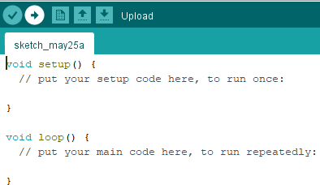

**FIGURE 3.5 TEXT AREA OF ARDUINO IDE**

**The Setup Function**: We must initialize and assign the variables we plan to utilize before beginning the setup. The setup process then begins, during which we set the initial condition of your variables and only run preparatory code once.

1. **The Setup Function**: We must initialize and assign the variables we plan to utilize before beginning the setup. The setup process then begins, during which we set the initial condition of your variables and only run preparatory code once.
2. **Loop routine:** The loop procedure is the code that runs or executes your main function repeatedly.

* **Message Window Area:** This is the dark section, where we'll get messages from the IDE, primarily regarding code variation. It also shows the error that occurs in the code.

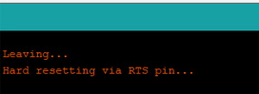

**FIGURE 3.6 MESSAGE WINDOW AREA OF ARDUINO**

**3.4.1.2 ARDUINO PROGRAMMING:**

The Arduino Programming Language is essentially a C++-based framework. You may argue that it isn't a true programming language in the classic sense, but I believe that this helps newcomers avoid misunderstanding.

Sketch is the name for a programme created in the Arduino Programming Language. The.ino extension is commonly used to preserve sketches (from Arduino).

##### **HANDLING I/O**

Following are the functions that help us with handling input and output from the Arduino device –

* **Digital I/O-**

**digitalRead()** reads a digital pin's value. Returns the HIGH or LOW constant when given a pin number as an input.

**digitalWrite()** sets the value of a digital output pin to HIGH or LOW. As parameters, you supply the pin number and HIGH or LOW.

**pinMode()** determines whether a pin is an input or an output. As arguments, you supply the pin number and the INPUT or OUTPUT value.

**pulseIn()** reads a digital pulse on a pin from LOW to HIGH and back to LOW, or from HIGH to LOW and back to HIGH. Until the pulse is detected, the programme will stop. You choose the pin number and the type of pulse to detect (LHL or HLH).

**pulseInLong()** function is similar to pulseIn(), but it is constructed differently and cannot be used if interrupts are disabled. Interrupts are frequently disabled in order to obtain a more precise result.

**shiftIn()** reads a byte of data from a pin one bit at a time.

**shiftOut()** writes one bit at a time to a pin a byte of data.

**tone()** transmits a square wave to a pin, which is used to play tones on buzzers and speakers. You may choose the pin as well as the frequency. It is compatible with both digital and analogue pins.

On a pin, noTone() pauses the tone() produced wave.

* **Analog I/O-**

**analogRead()** is a function that reads the value from an analogue

**analogReference()** sets the value for the analogue input's top input range,

which is by default 5V on 5V boards and 3.3V on 3.3V boards.

**analogWrite()** is a function that writes an analogue value to a pin.

analogReadResolution() function allows you to adjust the default analogue bit resolution for analogRead(), which is 10 bits by default. Only certain gadgets are compatible (Arduino Due, Zero and MKR).

**3.4.2 HARDWARE REQUIREMENTS**

**3.4.2.1 MLX90614 SENSOR (Temperature Sensor):**

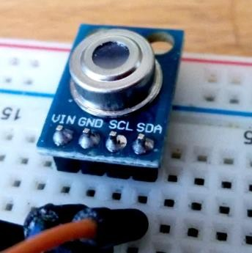The MLX90614 ESF is an Infra-Red thermometer for non-contact temperature measurements. Both the IR-sensitive thermopile detector chip and the signal conditioning ASIC are integrated into the same TO - 39 can. The Integrated MLX90614 GY-906 is a low noise amplifier, 17-bit ADC, and powerful DSP unit. The user can configure the digital output to be PWM. As a standard, the 10bit PWM is configured to continuously transmit the measured temperature in the range of -20 to 120 °C, with an output resolution of 0.14 °C.

**FIGURE 3.7 MLX90614 SENSOR**

* 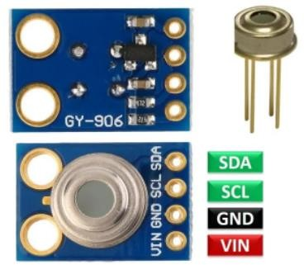**PINOUT OF MLX90614 SENSOR –**

**FIGURE 3.8: PINOUT OF MLX90614 SENSOR**

**TABLE NO 3.1 PINOUT OF MLX90614 SENSOR**

|  |  |
| --- | --- |
| **Pin Name** | **Description** |
| GND | This pin is connected to Ground |
| SCL/Vz | 2 wire communications protocol serial clock input This pin has a 5.7V Zener for connecting an external bipolar transistor to the MLX90614A in order to power the device from an external 8 -16V  source. |
| PWM/SDA | Input and output are both digital. The measured object temperature  is provided at this pin Pulse Width Modulated in normal mode. |
| VIN | External supply voltage. |

* **SPECIFICATION OF MLX90614 SENSOR**

**TABLE NO 3.2 SPECIFICATION OF MLX90614 SENSOR**

|  |  |
| --- | --- |
| **Parameters** | **Specification** |
| Operating Voltage | 3.6V to 5V (available in 3V and 5V  version) |
| Supply Current | 1.5mA |
| Object Temperature Range | -70° C to 382.2°C |
| Ambient Temperature Range | -40° C to 125°C |
| Accuracy | 0.02°C |
| Field of View | 80° |
| Distance between object and sensor | 2cm-5cm (approx.) |

**3.4.2.2 MAX30100 PULSE OXIMETER HEART RATE SENSOR**

MAX30100 is an integrated pulse Oximeter and heart-rate monitor sensor solution. It’s an optical sensor that derives its readings from emitting two wavelengths of light from two LEDs – a red and an infrared one – then measuring the absorbance of pulsing blood through a photo detector. This particular LED colour combination is optimized for reading the data through the tip of one’s finger. It is fully configurable through software registers and the digital output data is stored in a 16-deep FIFO within the device. It has an I2C digital interface to communicate with a host microcontroller.

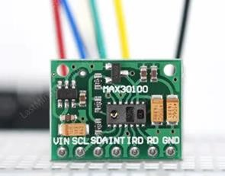

**FIGURE 3.9 MAX30100 PULSE OXIMETER HEART RATE SENSOR**

* **PINOUT OF MAX30100**

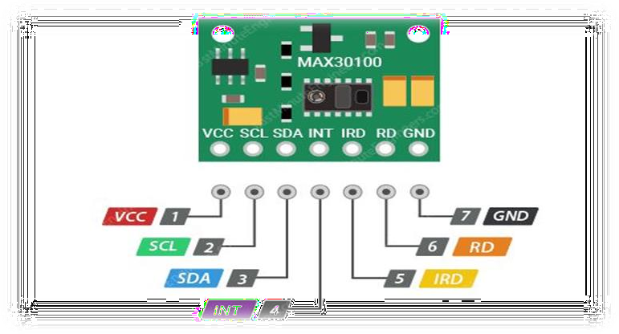

**FIGURE 3.10 PINOUT STRUCTURE OF MAX30100**

**TABLE NO 3.3 PINOUT OF MAX30100 SENSOR**

|  |  |
| --- | --- |
| **Pin name** | **Description** |
| Vin | Voltage input |
| Scl | I2c - serial clock |
| Sda | I2c - serial data |
| Int | Active low interrupt |
| Ird |  |
| Rd |  |
| Gnd |  |

* **SPECIFICATION OF MAX30100**

**TABLE NO 3.4 SPECIFICATION OF MAX30100 SENSOR**

|  |  |
| --- | --- |
| **PARAMETERS** | **SPECIFIATION** |
| Operating Voltage | 1.8V to 3.3V |
| Input Current | 20mA |
| Colour | Green |
| **S**ize | 19x14.5x3mm |

**3.4.2.3** **HC-05/HC-06 Bluetooth Module**

HC-05/HC-06 module Bluetooth SPP (Serial Port Protocol) module, designed for wireless serial connection setup. It has EDR (Enhanced Data Rate) of 3Mbps Modulation with a complete 2.4GHz radio transceiver and baseband. It uses the CSR Blue core 04-External single-chip Bluetooth system with CMOS technology and with AFH (Adaptive Frequency Hopping Feature).

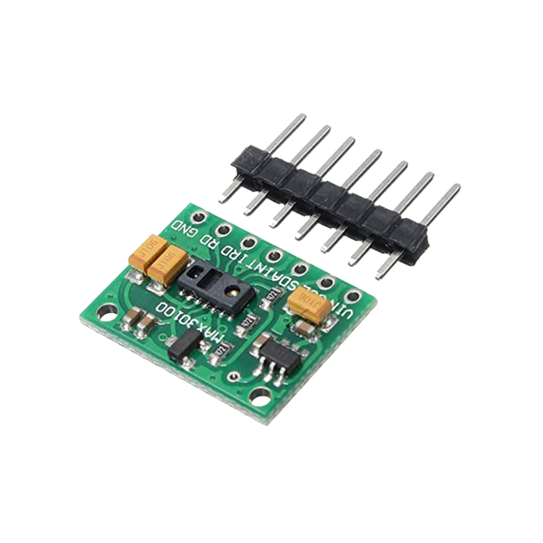

**FIGURE 3.11 HC-05/HC-06 Bluetooth Model**

* **PINOUT OF HC-05 Bluetooth Module**

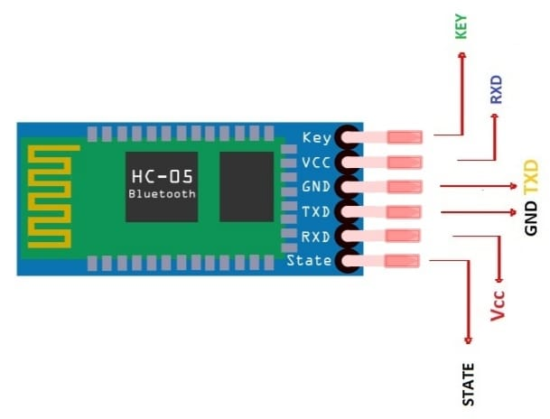

**FIGURE 3.12 PINOUT STRUCTURE OF HC-O5**

**TABLE NO 3.5 PINOUT OF HC-05**

|  |  |
| --- | --- |
| **Pin name** | **Description** |
| KEY | Pull high in AT/command mode |
| VCC | 3.6V TO 6V |
| GND |  |
| TXD | Connect to RXD of controller |
| RXD | Connect to TXD of controller |
| STATE | Connect to status LED |

* **SPECIFICATION OF HC-05**

**TABLE NO 3.6 SPECIFICATION OF HC-05**

|  |  |
| --- | --- |
| **PARAMETERS** | **SPECIFIATION** |
| Operating Voltage | 4V to 6V |
| Input Current | 30mA |
| Range | <100m |

##### **3.4.2.4 LCD 16×2**

A 16×2 LCD means it can display 16 characters per line and there are 2 such lines. In this LCD each character is displayed in a 5×7pixel matrix. This LCD has two registers, namely, Command and Data. The command register stores the command instructions given to the LCD. A command is an instruction given to LCD to do a predefined task like initializing it, clearing its screen, setting the cursor position, controlling display etc. The data register stores the data to be displayed on the LCD. The data is the ASCII value of the character to be displayed on the LCD. Click to learn more about the internal structure of an LCD.

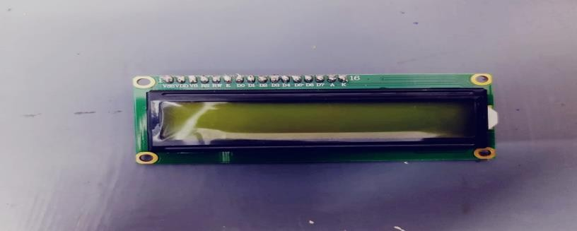

**FIGURE 3.15 LIQUID CRYSTAL DISPLAY(LCD)**

* **PINOUT DESCRIPTION OF LCD**

**TABLE NO 3.9 PINOUT CONFIGURATION OF LCD**

|  |  |
| --- | --- |
| **Pin name** | **Description** |
|  |  |
|  |  |
|  |  |
|  |  |
|  |  |
|  |  |
|  |  |
|  |  |
|  |  |

* **SPECIFICATION OF LCD**
* Operating Voltage is 4.7V to 5.3V.
* Current consumption is 1mA without backlight.
* Alphanumeric LCD display module, meaning can display alphabets and numbers.
* Consists of two rows and each row can print 16 characters.
* Each character is build by a 5×8 pixel box.
* Can work on both 8-bit and 4-bit mode.

**3.4.2.5 70x20mm Robot Wheel**

A wheel is a circular component that is intended to rotate on an axle bearing. The wheel is one of the key components of the wheel and axle which is one of the six simple machines. Wheels, in conjunction with axles, allow heavy objects to be moved easily facilitating movement or transportation while supporting a load, or performing level in machines. Wheels are also used for other purposes, such as a ship's wheel, steering wheel, potter's wheel and flywheel.

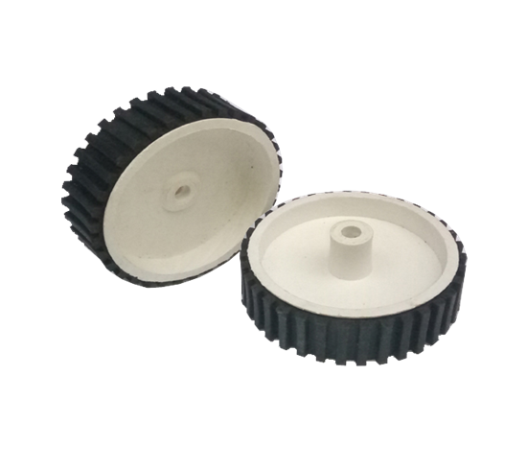

**FIGURE 3.16 ROBOT WHEEL**

**3.4.2.6 DC GEARED MOTOR**

DC Motor –60RPM – 12Volts geared motors are generally a simple DC motor with a gearbox attached to it. This can be used in all-terrain robots and a variety of robotic applications. These motors have a 3 mm threaded drill hole in the middle of the shaft thus making it simple to connect it to the wheels or any other mechanical assembly.

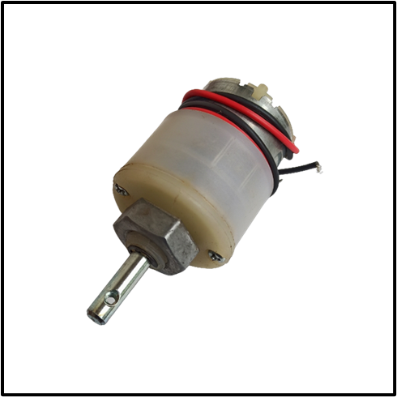

**FIGURE 3.17 DC GARED MOTOR**

**3.4.2.7 LM7805 Positive Voltage Regulator**

Fixed voltage Positive and Negative regulator ICs are used in circuits to give precise regulated voltage. 78 XX series regulator IC can handle a maximum of 1-ampere current. The Regulator ICs require a minimum 1.5 higher input voltage than their voltage rating. For example, the 7805 IC requires a minimum of 6.5 volts to give 5-volt output.

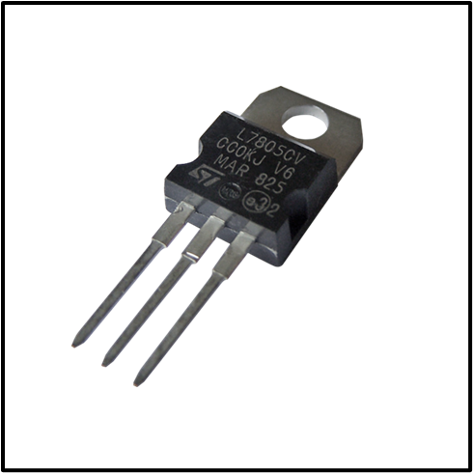

**FIGURE 3.18 VOLTAGE REGULATOR**

* **SPECIFICATION OF LM 7805 VOLTAGE REGULATOR**

**TABLE NO 3.10 SPECIFICATION OF LM 7805**

|  |  |
| --- | --- |
| **PARAMETERS** | **SPECIFIATION** |
| Operating Voltage | 7.5 Volt to 48 Volt |
| Output Voltage | 5V |
| Output Current | 1 Amp |

**3.4.2.8 MICROCONTROLLER (ATMEGA328P)**

The ATMEGA328P-PU is a low-power CMOS 8-bit microcontroller based on the AVR enhanced RISC architecture. By executing powerful instructions in a single clock cycle, the ATmega328P-PU achieves throughputs approaching 1 MIPS per MHz allowing the system designer to optimize power consumption versus processing speed. The AVR core combines a rich instruction set with 32 general purpose working registers.

* **PINOUT OF ATMEGA 328P**

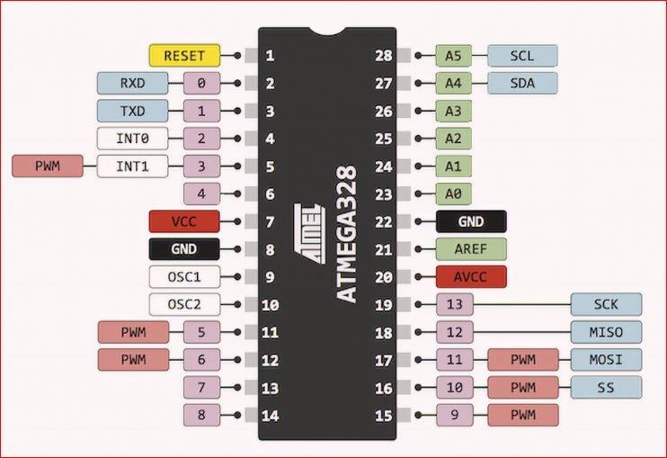

**FIGURE 3.19 PINOUT CONFIGURATION**

**TABLE 3.12 PINOUT CONFIGURATION OF ATMEGA 328P**

|  |  |  |
| --- | --- | --- |
| **Pin Description** | **Pin Function** | **Pin Function Description** |
| PC6 | Reset | When this reset pin goes low the microcontroller & its program gets reset. |
| PD0 | Digital Pin (RX) | Input pin for serial communication |
| PD1 | Digital Pin (TX) | Output pin for serial communication |
| PD2 | Digital Pin | Pin 4 is used as an external interrupt 0 |
| PD3 | Digital Pin | **FIGURE 3.18 PINOUT OF ATMEGA**  Pin 5 is used as an external interrupt 1 |
|  | (PWM) |  |
| PD4 | Digital Pin | Pin 6 is used for external counter source Timer0 |
| Vcc | Positive Voltage | Positive supply of the system. |
| GND | Ground | Ground of the system |
| XTAL | Crystal Oscillator | This pin should be connected to one pin of the crystal oscillator to provide external clock pulse to the chip |
| XTAL | Crystal Oscillator | This pin should also be connected to another pin of the crystal oscillator to provide external clock pulse to the chip |
| PD5 | Digital Pin (PWM) | Pin 11 is used for external counter source Timer1 |
| PD6 | Digital Pin (PWM) | Positive Analog Comparator i/ps |
| PD7 | Digital Pin | Negative Analog Comparator i/ps |
| PB0 | Digital Pin | Counter or Timer input source |
| PB1 | Digital Pin (PWM) | counter or timer compare match A. |
| PB2 | Digital Pin (PWM) | This pin is act as a slave choice i/p. |
| PB3 | Digital Pin (PWM) | This pin is used as a master data output and slave data input for SPI. |
| PB4 | Digital Pin | This pin is act as a master clock input and slave clock output. |
| PB5 | Digital Pin | This pin is act as a master clock output and slave clock input  for SPI. |
| AVcc | Positive Voltage | Positive voltage for ADC (power) |
| AREF | Analog Reference | Analog Reference voltage for ADC (Analog to Digital  Converter) |
| GND | Ground | Ground of the system |
| PC0 | Analog Input | Analog input digital value channel 0 |
| PC1 | Analog Input | Analog input digital value channel 1 |
| PC2 | Analog Input | Analog input digital value channel 2 |
| PC3 | Analog Input | Analog input digital value channel 3 |
| PC4 | Analog Input | Analog input digital value channel 4. This pin can also be used as serial interface connection for data. |

|  |  |  |
| --- | --- | --- |
| PC5 | Analog Input | Analog input digital value channel 5. This pin also used a serial interface clock line. |

* **SPECIFICATION OF ATMEGA 328**

|  |  |
| --- | --- |
| **PARAMETERS** | **SPECIFICATIONS** |
| IC TYPE | Avr microcontroller |
| CORE SIze | 8-bit |
| speed | 20 mhz |
| Number of i/o | 23 |
| Program memory size | 32kb(16k*16) |
| Program memory type | flash |
| Eeprom size | 1k*8 |
| Ram size | 2k*8 |

**TABLE 3.13 SPECIFICATION OF ATMEGA 328**

* **3.4.2.9 L293D Dual Motor Driver Module**

L293D contains two inbuilt H-bridge driver circuits. In its common mode of operation, two DC motors can be driven simultaneously, both in forward and reverse direction. The motor operations of two motors can be controlled by input logic at pins 2 & 7 and 10 & 15. Input logic 00 or 11 will stop the corresponding motor. Logic 01 and 10 will rotate it in clockwise and anticlockwise directions, respectively.

* **PINOUT OF L293D Dual Motor Driver**

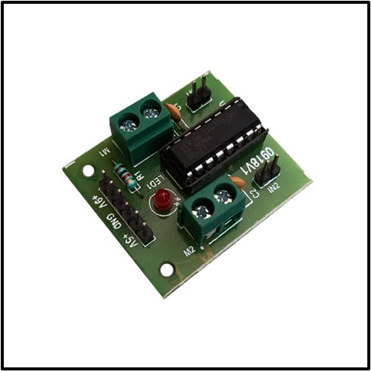

**FIGURE 3.20 L293D Dual MOTOR DRIVER**

* **SPECIFICATION OF L293D**
* Motor voltage Vcc2 (Vs): 4.5V to 36V.
* Maximum Peak motor current: 1.2A.
* Maximum Continuous Motor Current: 600mA.
* Supply Voltage to Vcc1(VCC): 4.5V to 7V.
* Transition time: 300ns (at 5Vand 24V).
* **3.4.2.10 12V DC BATTERY**

**3.5 IMPLEMENTATION**

**3.5.1 HARDWARE IMPLEMENTATION**

The implementation of hardware parts has been discussed with the help of the

modules discussed below-

**3.5.1.1 Module-**

**Development of Arduino board through PCB designing of it.**

There are three major reasons why you should consider utilizing Arduino to

prototype your idea and construct a PCB. The first is that Arduino are meant

to be extremely user- friendly. Regardless of how big or small your project is,

ease of use is critical across the whole product development lifecycle. Ease of

use will help you cut money while also reducing technical issues.

Another reason Arduino is great for making PCBs is that it is a completely

open-source architecture, which means you will never have to worry about

blocked rights, laws, code, or hardware. The following are the main reasons

why Arduino is ideal for your product prototype concept:

* + - * + Arduino is intended to be a user-friendly platform.
        + Arduino is a free and open-source platform.
        + Arduino boards are inexpensive

The following are the stages needed in converting an Arduino prototype to a

PCB: - Step 1: Create the Perfect Microcontroller Circuit for Your Prototype

Step 2: Create Custom Schematic Circuits for Your Favorite Arduino Shields.

Step 3: Create a PCB for your prototype.

Step 4: Purchasing Your First PCB Prototype and Placing an Order. Step 5:

Create your prototype's software and firmware.

Step 6: Putting Your Prototype to the Test in the Real World for the First Time.

**REFERENCES & BIBLIOGRAPHY**

1. S. M. R. Islam, D. Kwak, M. H. Kabir, M. Hossain and K. Kwak, **"The Internet of Things for Health Care: A Comprehensive Survey,"** In IEEE Access, vol. 3, pp. 678- 708, 2015.
2. S. H. Almotiri, M. A. Khan and M. A. Alghamdi, **"Mobile Health (m-Health) System in the Context of IoT,”**2016 IEEE 4th International Conference on Future Internet of Thing and Cloud Workshops, pp. 39-42, 2016.
3. Subham Banka, Isha Madan and S.S. Saranya, **“Smart Healthcare Monitoring using IoT”** International Journal of Applied Engineering Research ISSN 0973-4562 Volume 13, Number 15, pp. 11984-11989, 2018.
4. B. G. Ahn, Y. H. Noh, and D. U. Jeong, **“Smart chair based on multi heart rate detection system.”** In 2015 IEEE SENSORS, pp. 1–4, Nov 2015
5. I. Chiuchisan, H. N. Costin, and O. Geman. **“Adopting the internet of things technologies in health care systems.”** In 2014 International Conference and Exposition on Electrical and Power Engineering (EPE), pages 532– 535, Oct 2014.